Source https://www.viator.com/tours/Honolulu/Grand-Tour-Around-Island-with-Snorkeling-16-Locations/d59070-375182P1
__________________________________________________________

Ultimate Oahu Island Discovery Tour with Snorkeling & 16 Scenic Stops
__________________________________________________________
★★★★★ 4.5/5 20 reviews

Add to wishlist ♡

__________________________________________________________

8–10 Hours | €120 per person

🏕  Image | 🏕  Image | 🏕  Image | 🏕  Image | 🏕  Image | 🏕  Image

__________________________________________________________
Experience Overview
Discover Oahu’s most breathtaking landmarks in a single expertly guided journey designed to showcase the island’s natural beauty, culture, and history. This full-day island adventure combines scenic viewpoints, famous beaches, tropical farms, and historic sites with a refreshing snorkeling session in crystal-clear waters. With hotel pickup, snacks, and equipment included, the experience offers a seamless and enriching way to explore Hawaii’s most iconic locations in comfort.
__________________________________________________________
Tour Snapshot
- Duration: 8–10 hours
- Meeting Point: Pickup from selected Honolulu hotels or assigned nearby pickup location
- Group Size: Up to 50 participants
- Accommodation: Not included (day tour experience)
- Languages Available: English
- Private Guide: Not included (shared guided tour)
- Transportation: Air-conditioned vehicle included
- Season: Available year-round
__________________________________________________________

Check Dates & Availability

Select participants: (Age 99 and younger) - 1 +

Choose date:
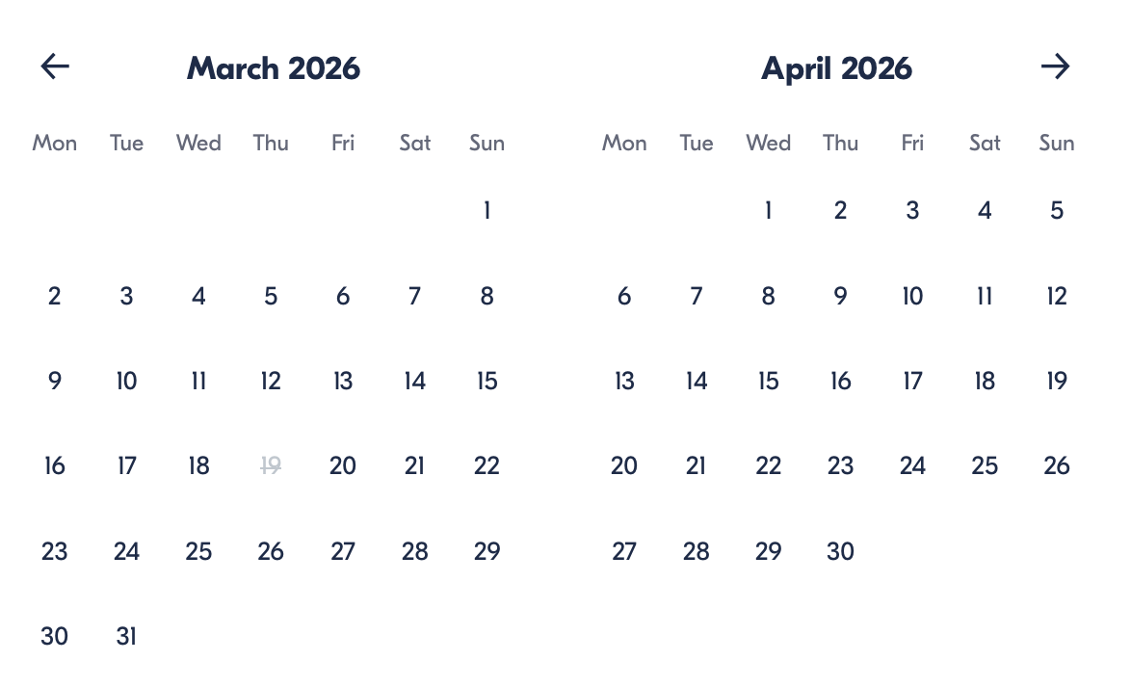

Check Availability

opens:

Participants: 1 March 16, 2026

Ultimate Oahu Island Discovery Tour with Snorkeling & 16 Scenic Stops

- Duration: 8–10 hours
- Offered in: English
- Starts at: 7:00 AM

Cancellation:

- More than 24 hours before start: Full refund
- Less than 24 hours before start: No refund

Price breakdown: 1 Participant x €120

Total: €120

The total price includes all taxes and fees.

Add to cart Book now

__________________________________________________________
Tour Highlights
- 16 Island Stops: Visit a wide selection of Oahu’s most celebrated scenic and cultural landmarks in one day.
- Snorkeling Experience: Swim among colorful marine life at a North Shore beach.
- Iconic Coastal Views: Enjoy spectacular viewpoints, including Diamond Head and Halona Blowhole.
- Local Farm Visits: Discover Hawaiian produce, coffee, and macadamia farms.
- Famous Beaches: Explore legendary locations such as Waimea Bay and Sandy Beach.
__________________________________________________________
Detailed Itinerary
Start – Hotel Pickup & Island Departure
Your adventure begins with convenient pickup from your Honolulu accommodation or a nearby designated meeting point. Travel comfortably in an air-conditioned vehicle as your guide introduces the island’s history and highlights.

Scenic South Shore & Coastal Lookouts
Admire panoramic ocean views from elevated vantage points near Diamond Head and observe the powerful natural geyser of Halona Blowhole. Continue to Sandy Beach Park, famous for its golden sands and dramatic shorebreak waves.

Windward Coast & Cultural Stops
Pass through Waimanalo and browse local souvenir shops before stopping to admire Mokoliʻi Island, often called Chinaman’s Hat because of its distinctive shape.

North Shore Snorkeling Adventure
Spend about an hour snorkeling in clear tropical waters along Oahu’s North Shore, where vibrant fish and marine life create an unforgettable underwater experience.

Farm & Plantation Discoveries
Visit Kahuku Farms and the North Shore Macadamia Nut Company to sample local products. Continue to the renowned Dole Plantation to learn about Hawaii’s pineapple heritage, then explore Green World Coffee Farm and watch local beans roasted onsite.

Beach & Wildlife Viewing
Stop at Puaʻena Point Beach Park, also known as Turtle Beach, where sea turtles are frequently spotted resting along the shore.

Final Stop – Waimea Bay
Experience one of Hawaii’s most legendary beaches, famous for massive winter surf and historic big-wave competitions.

Return Transfer
Relax during your comfortable ride back to your hotel after a full day of exploration.
__________________________________________________________
Included in Price
- Guided island tour experience
- Hotel pickup and drop-off from selected locations
- Snorkeling equipment
- Snacks and bottled water
- Air-conditioned transportation
__________________________________________________________
Not Included
- Wetsuit rental (optional extra)
- Professional photos (optional purchase)
- Gratuities for guide and driver
__________________________________________________________
Who Should Avoid This Tour
- Wheelchair users
- Infants who require individual seating
- Travelers with mobility limitations affecting boarding or walking
__________________________________________________________
Important Trip Info
- Tour Length: The experience lasts approximately 8–10 hours, including travel time between stops.
- Pickup Instructions: Exact pickup details are confirmed after booking. Some locations may require a short walk to a designated pickup point.
- Weather Notice: Certain stops may be modified or replaced depending on conditions.
- Participation: Most travelers can take part, and confirmation is provided within 48 hours, subject to availability.
- Group Size: Maximum 50 travelers per departure.
__________________________________________________________

Cancellation Policy
Free cancellation up to 24 hours before the scheduled start time.

- Cancellations within 24 hours of departure are non-refundable.
- Changes requested less than 24 hours before departure cannot be processed.

Weather cancellations or insufficient participant numbers qualify for either rescheduling or a full refund.
__________________________________________________________
What Our Clients Are Saying

Overall rating  4.5/5  ★★★★★  Based on 20 reviews | Review summary  Guide 4.5/5  Transportation 4.6/5  Service 4.7/5  Organisation 4.5/5

Filter  - All traveller types  - Couples  - Group of friends  - Families  By star rating  - All star ratings  - 5 stars  - 4 stars  - 3 stars  - 2 stars  - 1 star | Search reviews (e.g., guide)  Sort by:  - Top picks  - Latest reviews  - Best ratings  - Lowest ratings
__________________________________________________________
★★★★★
Marco L. — Italy
An incredible way to see Oahu! Every stop revealed something new, and snorkeling with tropical fish was unforgettable.
★★★★★
Isabelle R. — France
A fantastic island overview in one day. The guide was knowledgeable and made every location interesting and fun.
★★★★☆
Daniel P. — Canada
Great tour with beautiful scenery and lots of variety. It felt a little fast-paced, but we still saw so much.
See more reviews
__________________________________________________________

Meta tags

Page - Ultimate Oahu Island Discovery Tour with Snorkeling & 16 Scenic Stops

Title: Oahu Grand Island Tour with Snorkeling | Travellio Global

Description: Explore Oahu’s top attractions on a full-day guided tour featuring 16 scenic stops, snorkeling, farm visits, and iconic Hawaiian beaches.

H1 - Ultimate Oahu Island Discovery Tour with Snorkeling & 16 Scenic Stops
__________________________________________________________

